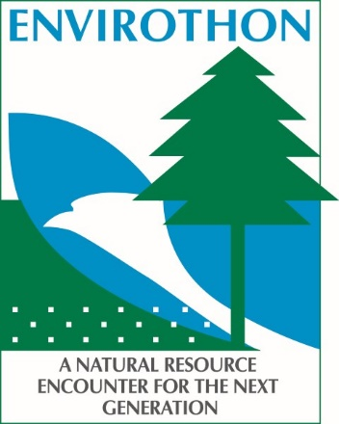
2023 Iowa Envirothon
Put together your five-member team TODAY!
Please complete a separate form for each team registration.

Registrations due by Friday, March 3, 2023

School or Club Name
FFA Team

Team Advisor/Coach Address City State Zip Email Phone
Regional competitions will be held virtually this year. The tests will be available to take online between Monday, March 13th through Friday, March 24th. To access these tests, you will need to assign a proctor that will supervise the teams while they take the tests, the proctor must be a faculty member at the team’s school. The proctor will receive an email for each test that will contain a link to the online test, and a passcode that will be required to access the test, proctors MUST remain with the team until testing is complete.
Submit registration and payment to:
Conservation Districts of Iowa Attn: Iowa Envirothon
2015 Grand Ave Box #15 Ste LL2
Des Moines, IA 50312
Email: carlee@cdiowa.org

Proctor Name: _________________________________

Position: ______________________________________

Email: ________________________________________

$80.00 registration fee per team registration
Make Checks Payable to Conservation Districts of Iowa

Registration is not confirmed until receipt of payment.

Schools often take quite a bit of time to process payments, so please get your request in to your school for the Iowa Envirothon registration fee right away!

Registration fees cover both Regional and State Competition fees for teams who compete at each event. Upon receiving registration and payment, a confirmation of receipt will include further information for both events as they occur.

Questions: Contact Carlee Sabus at 515-289-8300 or carlee@cdiowa.org.

